2019

**Submitted By :**

Akul Bindal

RA1711003030085

SRM Institute Of Science And Technology

**Submitted To :**

Mr. Vivek Bhatnagar

( School Of

Computer Education )

**PROJECT FILE**

**ON BANK MANAGEMENT SYSTEM**

**Index**

1. **Cover Page**
2. **Index**
3. **Introduction**
4. **Output**
5. **Bibliography**

**Introduction**

Bank Management System is based on recording customer’s account details. Here the user can perform all the tasks like creating an account, deposit amount, withdraw amount, check balance, view all account holders detail, close an account and modify an account. There’s no login system for this project. All the main features for banking management system are set in this project.

Talking about the features of the Bank Management System, a user can create an account by providing the name of the account holder, account number, select amount type whether it’s Saving account or Current account and providing an initial amount. Then the user can also deposit and withdraw money just by providing his/her account, then the system displays his/her profile and entering an amount. For certain purpose, he/she can also check for the balance inquiry which displays the account holder’s name with account number type and amount. He/she can also check for all the account holder’s list. Another feature is that the user can also close their account by providing their account number and he/she can modify their account detail and type if they want to.

This project is made using classes and file handling features of C++. In order to store all the user’s data, an external file (DAT file) is created by the system, so every time we get into the system we can operate with the existing accounts. Banking Management System is developed using C++ Programming Language and different variables, strings have been used for the development of it. This project provides the simplest system for managing banking system.

**Output**

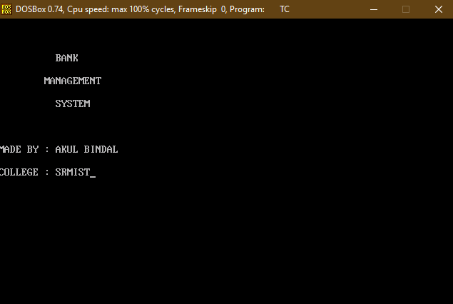

This is the opening page of the banking management system project.And below is the menu of the banking system that shows its several functions that it can do for us(customers).

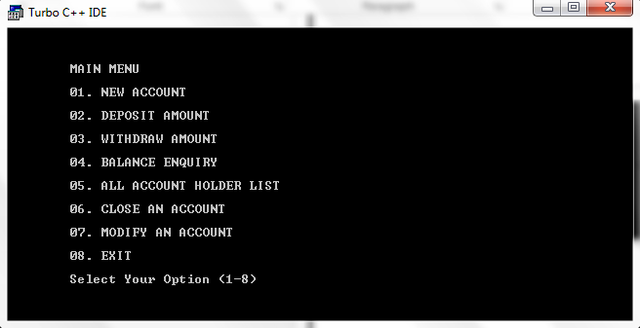

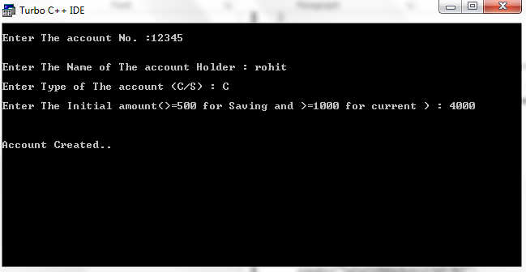**Add Record :**  
For this feature void read_data() function has been used to add banking record into the file. It asks for information such as account number, first name, last name and balance to be entered.

In the below screenshot we have added some amount to account with respect to the account details provided.

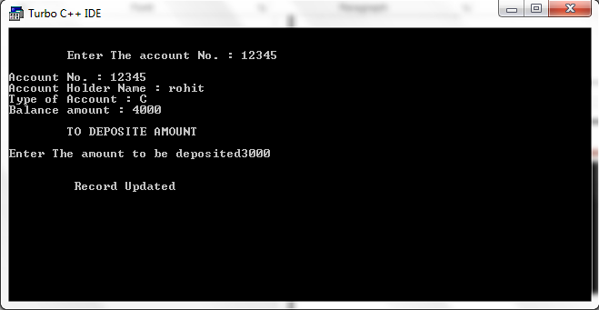

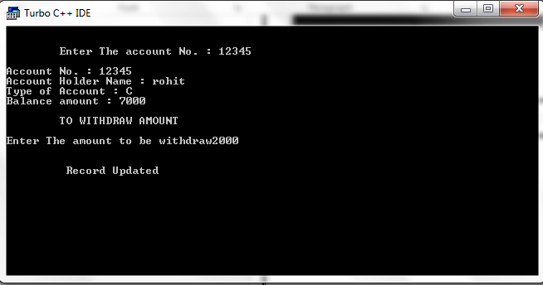

In the above we have withdrawn some amount from the account with respect to the account details provided.

In the below screenshot we have printed all the available records present in the system i.e. the option 5 ALL ACCOUNT HOLDER LIST.

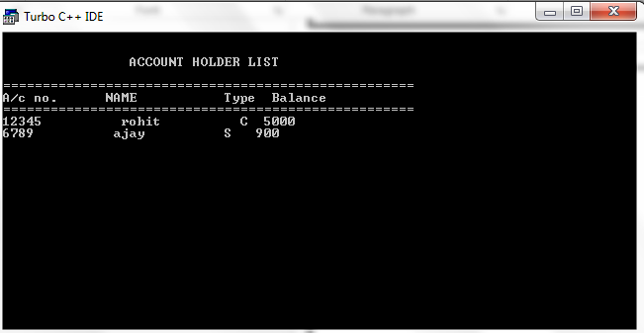

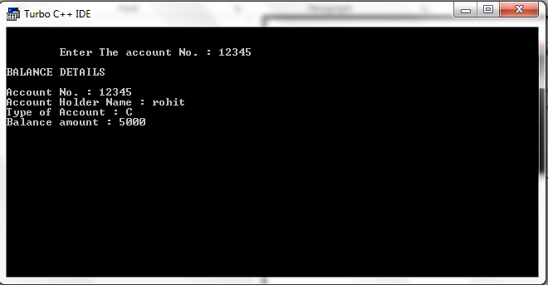**Show/List Data:**  
With the information provided in add record, the void show_data() function in this banking record system project in C++ show the record corresponding to a particular account number, first name and last name. Current balance of the account holder is displayed.

**Delete Record:**  
First of all, when the function of this feature is executed, it shows all the records in the file, and the user can enter the record number to delete. If the record was not found, this banking record system project in C++ displays the message – “Error in opening! File Not Found!!”

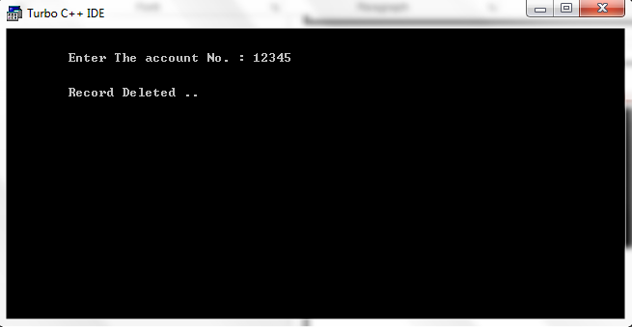

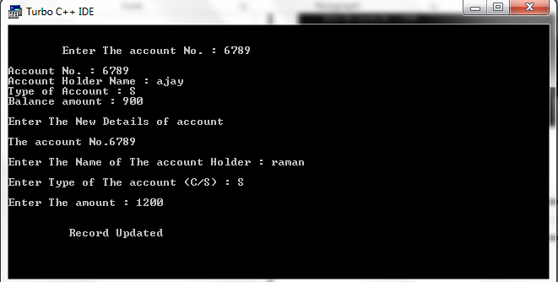**Edit Record:**  
This works in similar manner to the Search feature. When the function for Edit Record is first executed, it shows the total records in the file, and the user can edit the information by providing record number. Then, the C++ project shows all the data in that record, and the user can enter any data to modify. If the record to be edited for is not found, it displays the message – “Error in opening! File Not Found!!”

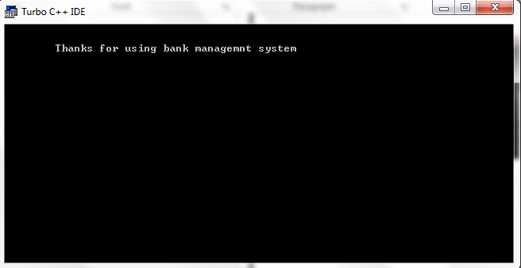The screen below is the exit page of this Banking Management System.

**Bibliography**

1. [www.cplusplus.com](http://www.cplusplus.com)
2. [www.learncpp.com](http://www.learncpp.com)
3. [www.cprogramming.com](http://www.cprogramming.com)